C:\Users\Abena Appiah-Kerr\AppData\Local\Microsoft\Windows\Temporary Internet Files\Content.IE5\YVOH7927\MC900237940[1].wmf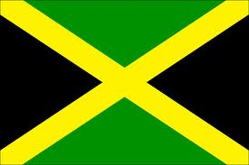C:\Users\Abena Appiah-Kerr\AppData\Local\Microsoft\Windows\Temporary Internet Files\Content.IE5\YVOH7927\MC900237940[1].wmf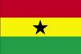C:\Users\Abena Appiah-Kerr\AppData\Local\Microsoft\Windows\Temporary Internet Files\Content.IE5\YVOH7927\MC900237940[1].wmf

This year is very important as some African countries celebrate 50 years of independence. How did your family celebrate Africa’s 50th birthday? Or, how does your family celebrate your country’s independence and why is it important.

*By: Khalid Kerr*

*Age: 10 years old*

Outside of the requirements of my faith or religion, in the last year, I supported my African community in the following ways: I have contributed to fun events for people of different ages and mainly of African descent living in my area and close to my area, by doing presentations, showing my dance and gymnastic moves because I enjoy talking about things that mean a lot to me e.g. being dyslexic , believing in yourself; I love dancing and I train 4 times a week with a gym club called ‘Southwark Gymnastic Club”.

This year is very important as some African countries celebrate 50 years of independence. How did your family celebrate Africa’s 50th birthday? Or, how does your family celebrate your country’s independence and why is it important.

I have chosen to mainly look at Jamaica and Ghana because my parents originate from these two countries. I have been able to pick up information from my observations on my visits to Jamaica and Ghana.

Most people think of beautiful beaches when the island of Jamaica is mentioned but there are many different types of places and people from different parts of the world on this island. I saw places that were called shanty towns in Kingston, that looked run down compared to other places that were really built up. Slaves were brought from Africa by the British around 1655 to work on the island, slavery was abolished in 1807 and Jamaica became independent in 1962 although the British Queen was the head of state.

In 1957 Ghana became the first country in colonial Africa to gain independence. Kumasi is the second largest city in Ghana with 400,000 people living there; it was founded in 1695 as the place for the Asante Empire. Kumasi is the centre of cultural life for the Asante people and this is where the king, Asantehene lives in his palace. Kumasi is described as the centre of gold-mining and the cocoa growing region. This is what brings in money but when I went there it looked really busy it also looked poor.

Why do cities in independent countries not look richer?

How I celebrate Independence Day

My parents do not believe in or celebrate Independence Day because my mother thinks it is not right for anybody to come along and say your country is now yours. The way I see it, just because a country gets independence doesn’t mean they are independent because most of the time the British and Americans control what countries like Jamaica and Ghana sell and how much they will pay for these things and so control what they have and it goes in a circle so it does not seem as if there is really such a thing as independence, independent countries in places that the western world like to call ‘developing’ are actually dependent countries and so should we be celebrating Dependence Day?

George Monbiot (2005) wrote that to become eligible for help, African countries must bring about “a market-based” economy that protects private property rights”, “the elimination of barriers to the United States trade and investment” and conducive environment for US “foreign policy interests “. In return they will be allowed “preferential treatment“for some of their products in the US markets. This means the clothes from Africa will sell in the US if the cloth used was made and cut in the US or they do not compete with those that have been made in the US.

There are situations when people who live in these “Independent Developing” countries are struggling and suffering because things are taken away from them, for example their land, food is bought to fill the selves of supermarkets or the food is changed into different forms to be used in “Developed” countries like Britain and the US.

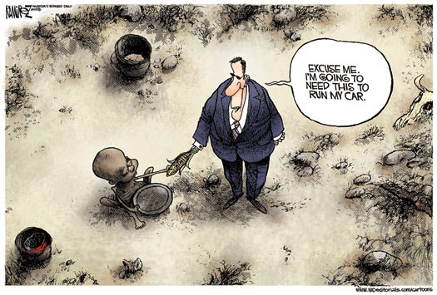Agrofood-feed-fuel complex & the land grab

Philip McMichael Cornell University

Conclusion

There should not be such a thing as Independence Day because really, the countries that gain independence have ended up being dependent and not independent. People of African descent must get together and think about and plan how this struggling and suffering can be stopped. Also, look at how we can share things instead of things being taken away from some so others have more and leaving them with so little or nothing. Maybe every country in the world can have a day to celebrate “Dependence Day” looking back in their history because we all have to depend on each other to live well. It is hard to understand why some countries do not have Independence Day is this because they are better and more powerful? NO! We need to all be the same.

**Bibliography**

Bastyra, J (2005) Living in Jamaica. London: Franklin Watts

Brownlie, A (2000) Country Insights: Jamaica. England: Wayland Publishers Ltd

La Pierre,Y (2004) Ghana in Pictures. America: Lerner Publications Company

McMicheal, P (2010) CFS Presentation. Rome: Cornell University – [online]. Available at http://www.tni.org/article/tni-sponsored-land-grabbing-side-event-fao-food-security-world-committee-session-rome-2010

Monbiot, G (2005) Africa’s New Best Friends. London: The Guardian – [online]. Available at http://www.commondreams.org/views05/0705-29.htm

Porter, M and Lye, K (2008) Continents in Close Up: Africa. Spain: Cherrytree Books

C:\Users\Abena Appiah-Kerr\AppData\Local\Microsoft\Windows\Temporary Internet Files\Content.IE5\YVOH7927\MC900237940[1].wmf