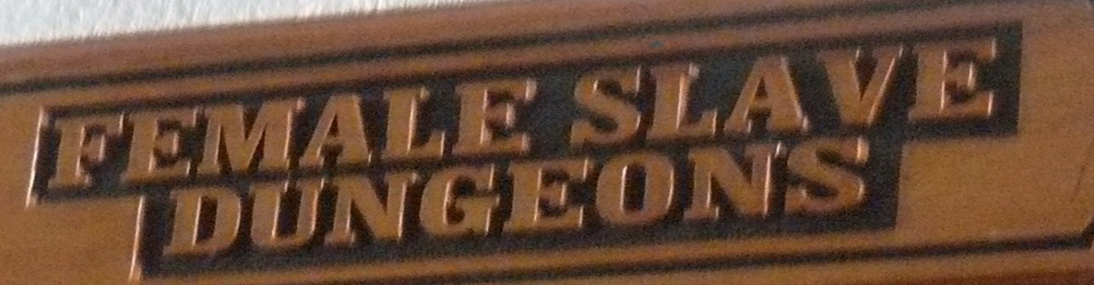

Think before you act

C:\Users\Abena Appiah-Kerr\AppData\Local\Microsoft\Windows\Temporary Internet Files\Content.IE5\EFPKZ5NH\MCPE03086_0000[1].wmf

Name: Khalid Kerr

Age: 9

****

**People of African descent in general are given little respect by the west, we should respect our brother’s and sister’s in Africa and the African Diasporas because... we are great people even though the West think the colour of our skin and the history of our ancestors being trapped and being taken across the seas makes them better than us, we must respect each other as a way of moving on.**

***Why is it important that you think before you act from a young age? What can be the consequences (result) if you do not think before you act? Give examples of what happened to you.***

**I go to Brunswick Park Primary School and I think this boy called Ty who comes from Africa and has got problems. He causes trouble for everybody in my class but we have learnt to understand that he has a problem and this might be because of his history, things that happen when he was younger. It looks like he gets away with the bad things he is doing.**

**Maybe when Ty was a baby his mother said to herself, “I will always love you Ty -**

**You are my baby and I do not want to let you go and slip through my fingers like butter”. She may have thought he will never be bad !BUT! No one can predict the future.**

**When other people who do not really get into trouble get into a fight with Ty and they say bad words, in the end they should regret this because they do not know where he comes from, maybe his dad died they do not know.**

**You should think before you act at a young age because if you carry on you will be angry all your life. If you see an old lady on the road you should not say:**

**“Mummy, mummy she looks so ugly and she is old she has no life. ’**

**That’s not a nice habit to have but even if older people do, it does not mean you should do what they do.**

**This is what would have been better to say at a young age “she is old, let me help her.”**

**That’s what we as African people have been brought up to do.**

**Another example of how we act is, if you lose your home that you loved and cared for and it is burning right in front of you then you will know how it feels for people who are so angry because something has happened in their life. This is because you may take your sadness about your home out on someone else but what have they done to you, think to yourself who is in the wrong? If you say it is him or her, you are actually in the wrong. When you are in a fight, argument, gang or shouting**

**!THINK! What are you doing? What would Jesus Christ do? Pray and pray then put it in the hands of God.**

**What I am trying to share with people is that there are times when some people find it difficult to control bad things that they do maybe because something has happened in their lives. There are other young people who can control themselves and should keep making good choices so they can grow up to be RESPONSIBLE grownups *(A word my father always talks to me about)*. Those of us who can make the right choices should help people like Ty so he can also learn to make the right choices and grow up to be a better person because that will be good for everybody not just Ty, we will be able to learn more instead of our teacher stopping to deal with him. If you choose to think about your actions this will help to make sure you have a good adult life, not end up in prison, learn more so you can get a job and you will not have to do crime to live.**

**We as African people should learn from what our ancestors went through when they were slaves in the past, they had to think about their actions and now we do not have that horrible thing called the slave trade anymore because of people thinking before they acted over the years we now have GOODNESS. Even here in Britain we can walk on the street without being called racist names all the time like what we see on TV programmes showing a long time ago.**

**The Door of No Return that I saw in Ghana at Cape Coast Castle where the slaves were taken to be shipped out – we can use this in a good way to say to ourselves that we will always think of our actions and Never Return to those horrible times of the slave trade and Britain a long time ago.**